# NationBuilder Programming Challenge

Design and Test File

Name: Yu Zhang

Date: Feb 16, 2015/2/16

Email: [yuzhang@cmu.edu](mailto:yuzhang@cmu.edu)

Address: 1063 morse ave, sunyvale, CA

1. Overview

The project use Ruby On Rails to develop.

<https://github.com/yuzhangcmu/ChatRoom_REST_API>

Because “type” and “date” is reserved by the SQL, so I use “event_type” and “event_type” to replace them.

1. How to run

Enter the “code” folder, then run “rails s” to run the server.

Then we can access the web server through the URL:

<http://127.0.0.1:3000/events>

1. Test Cases

## Submit Event

The Test Tool:

chrome-extension://hgmloofddffdnphfgcellkdfbfbjeloo/RestClient.html#RequestPlace:default

submit URL:

<http://127.0.0.1:3000/events>

User enters the room:

{"event_date":"2015-12-30T23:59:59Z", "user": "Alice", "event_type": "enter"}

Result:

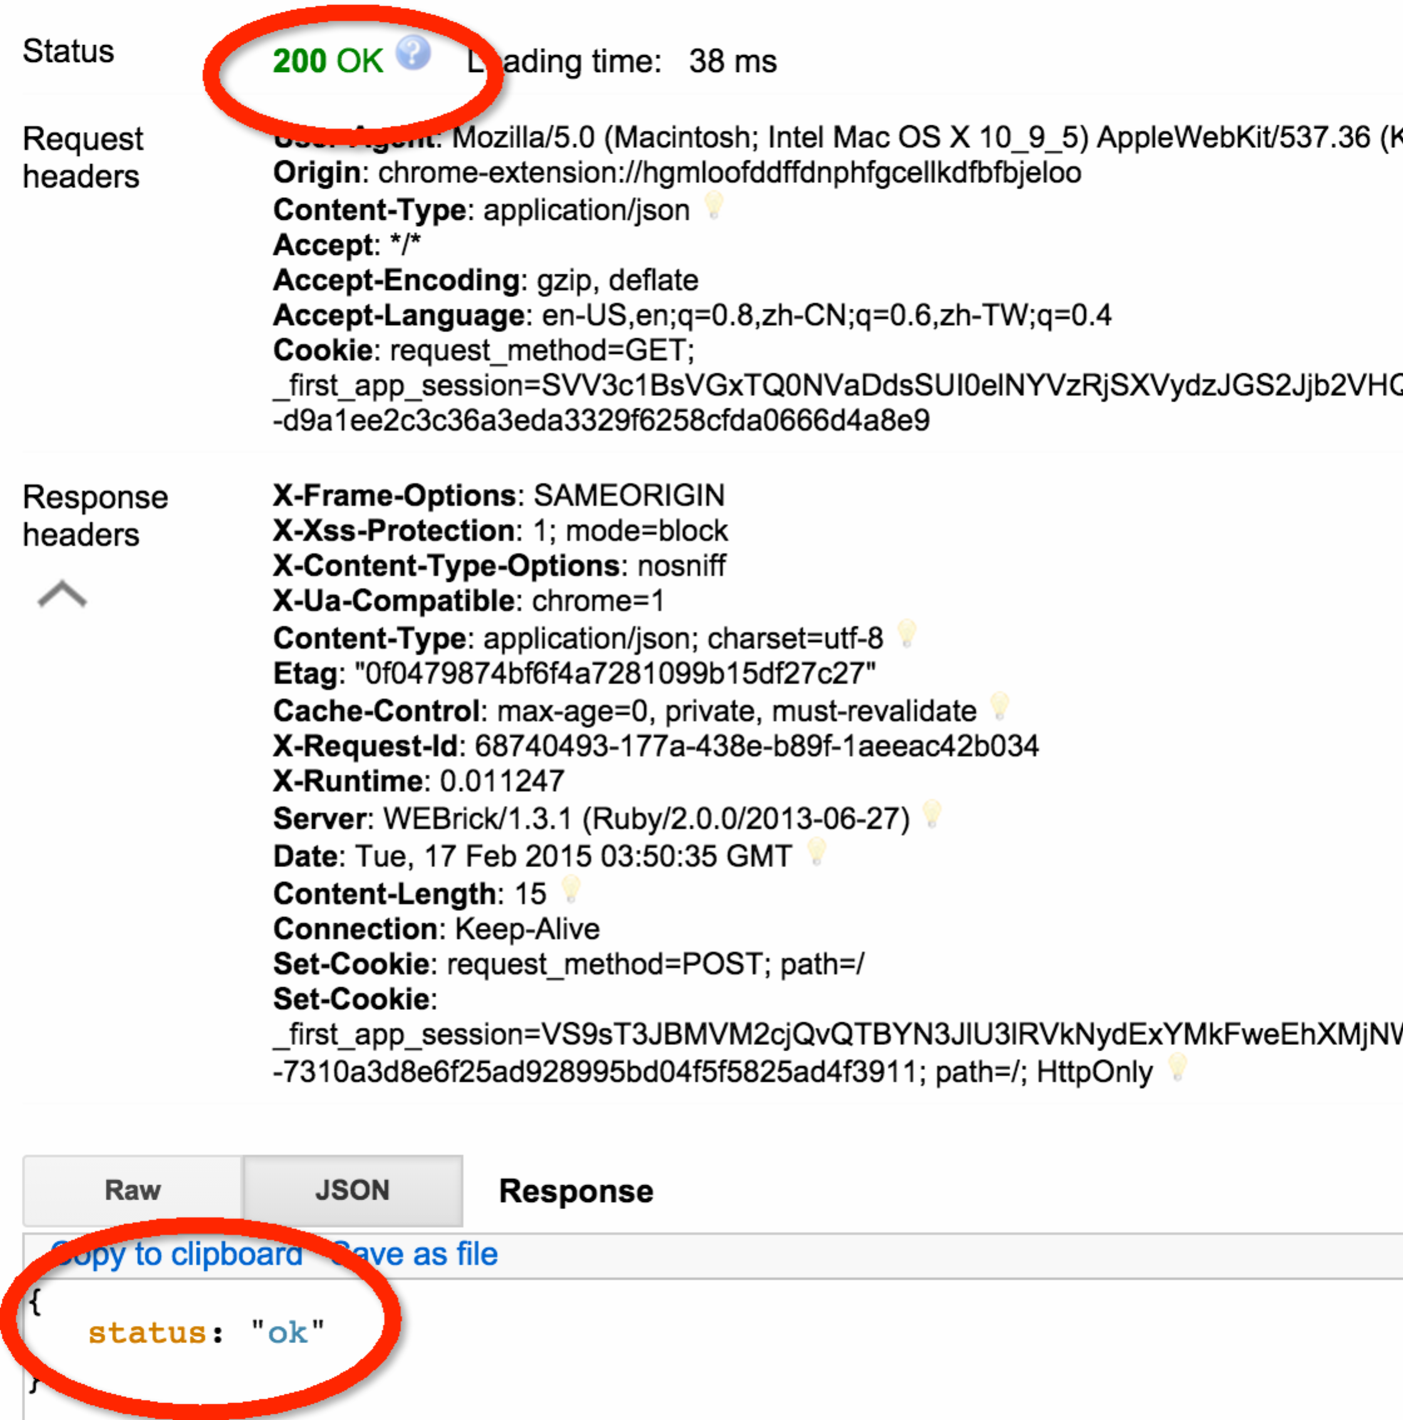

The enter event is added to the list:

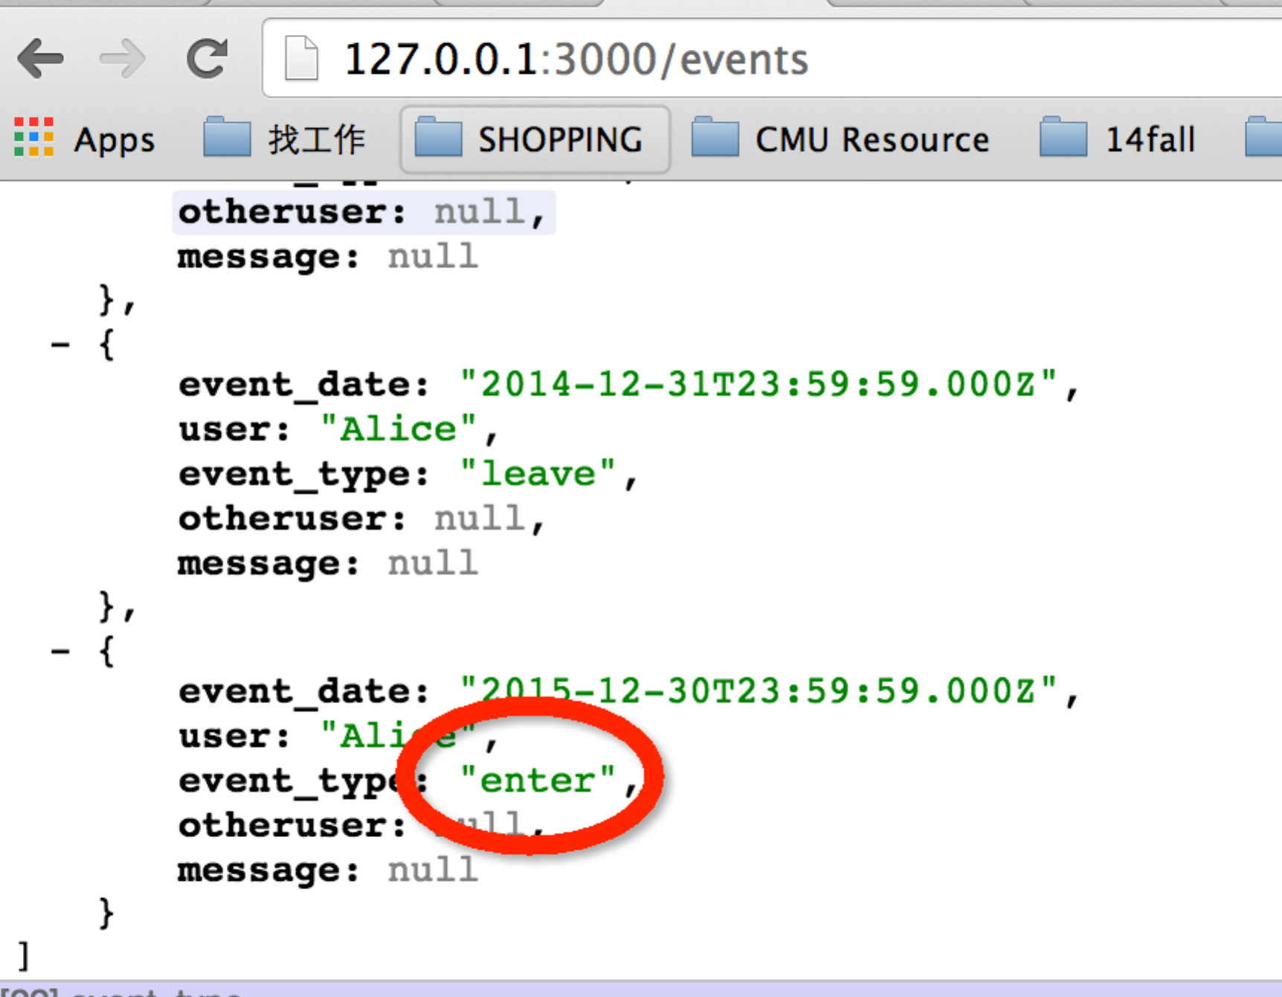

User comments in a room:

{"event_date":"2015-12-30T23:59:59Z", "user": "Alice", "event_type": "comment", "message": "hello, this is a sample message"}

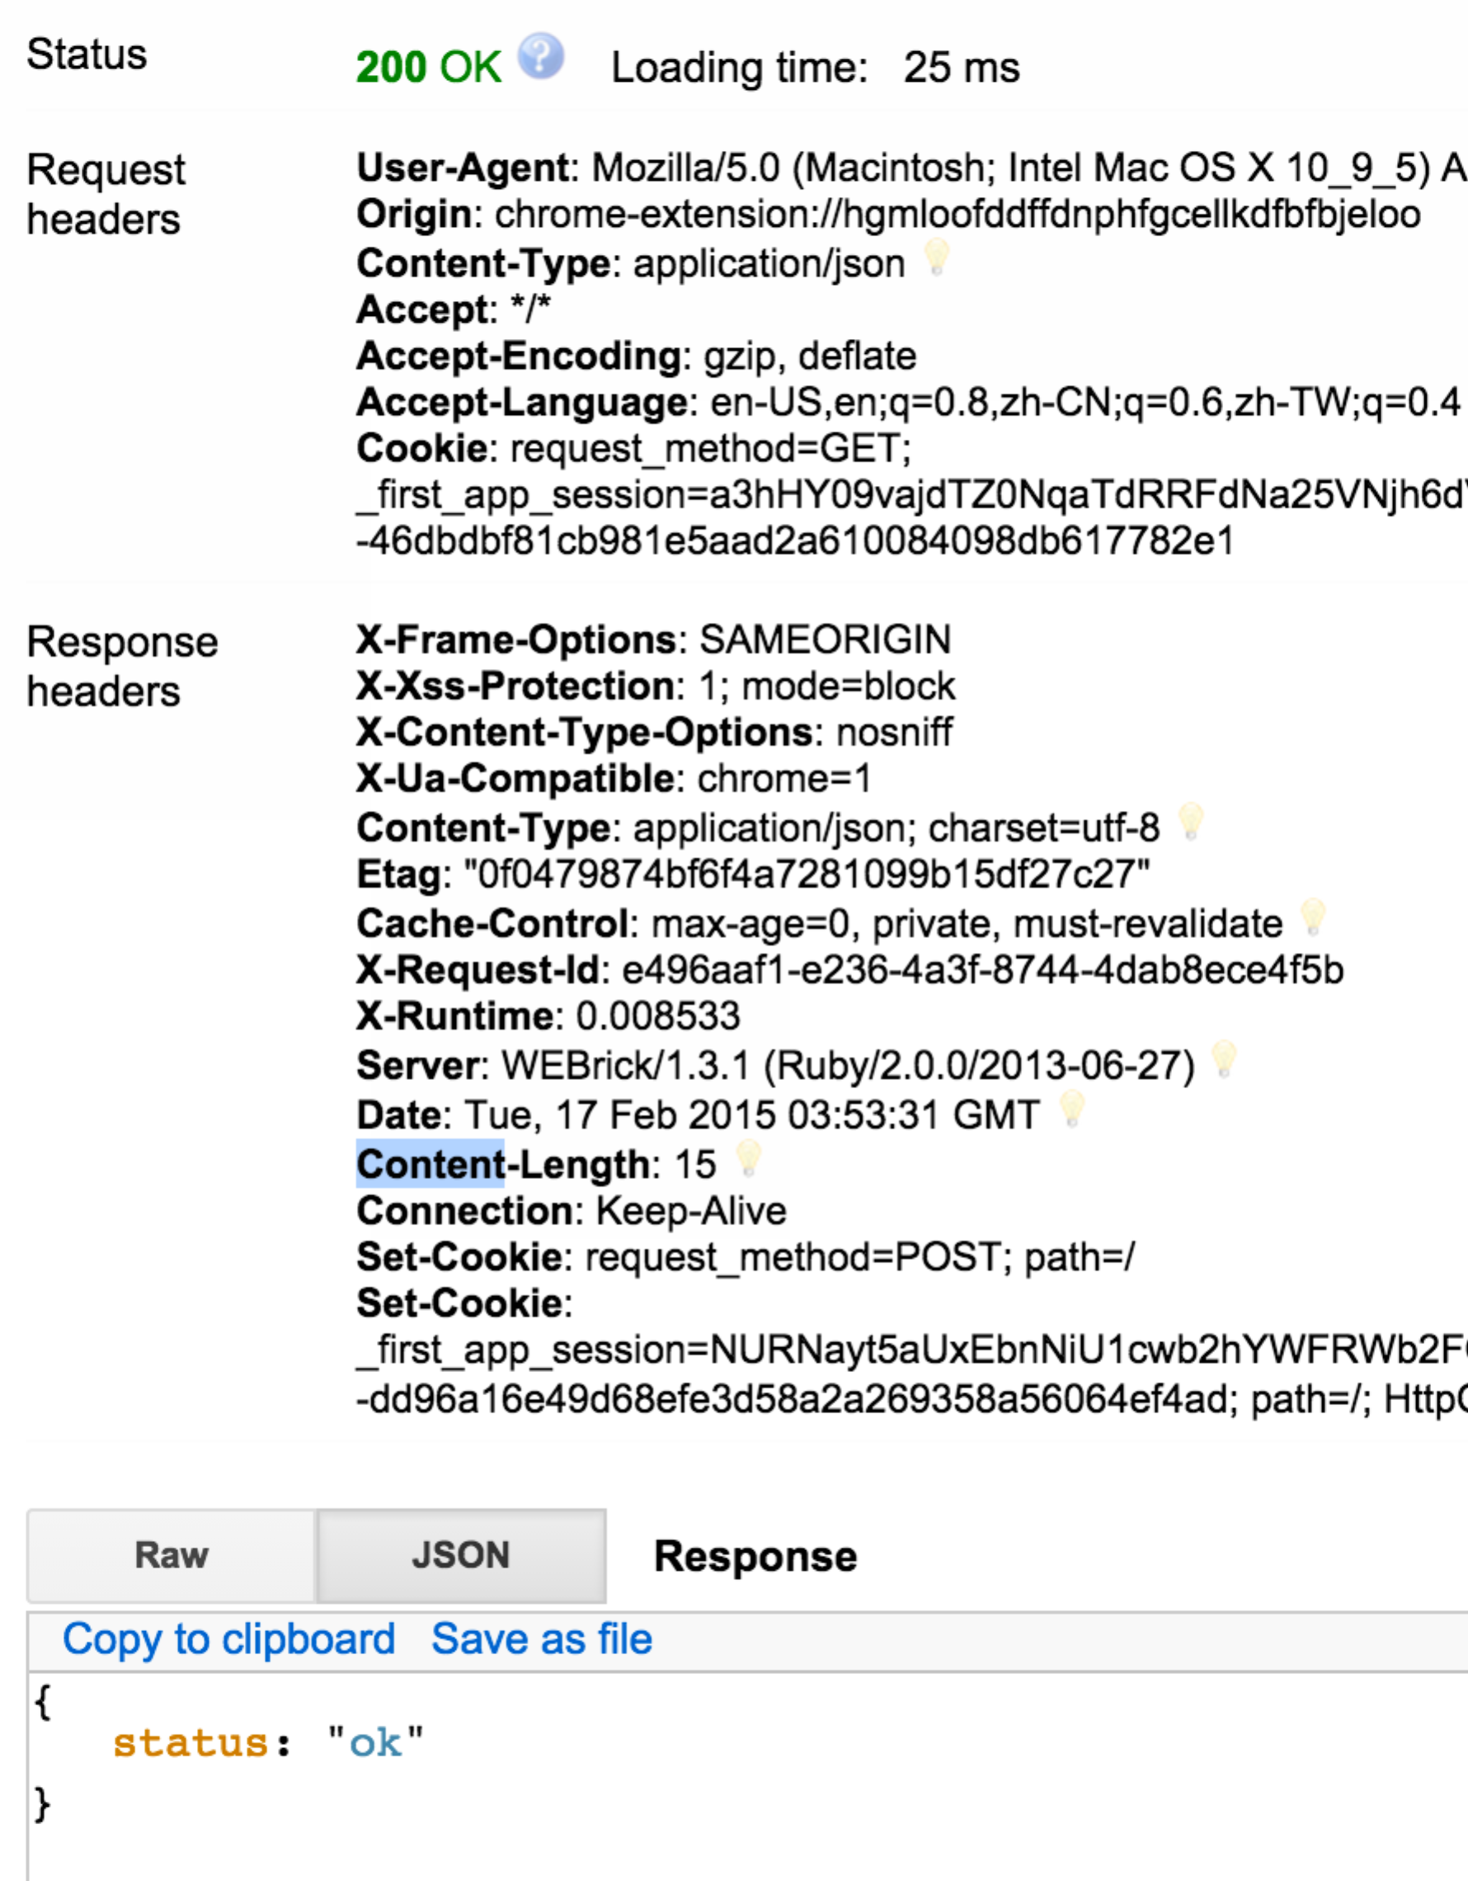

The event is added into the list:

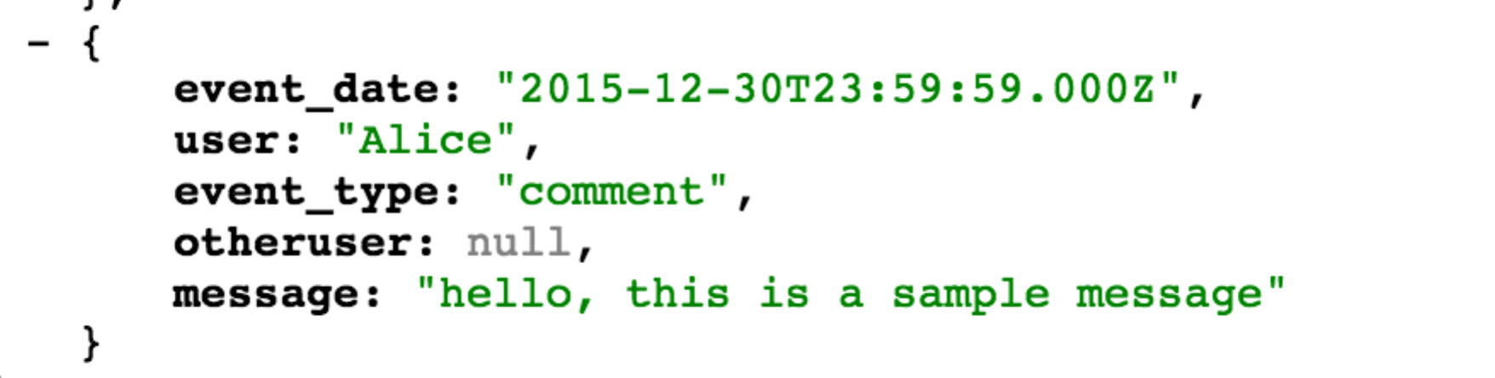

User “high­fives” another user:

{"event_date":"2015-12-30T23:59:59Z", "user": "Alice", "event_type": "highfive", "otheruser": "Bob"}

REPLY:

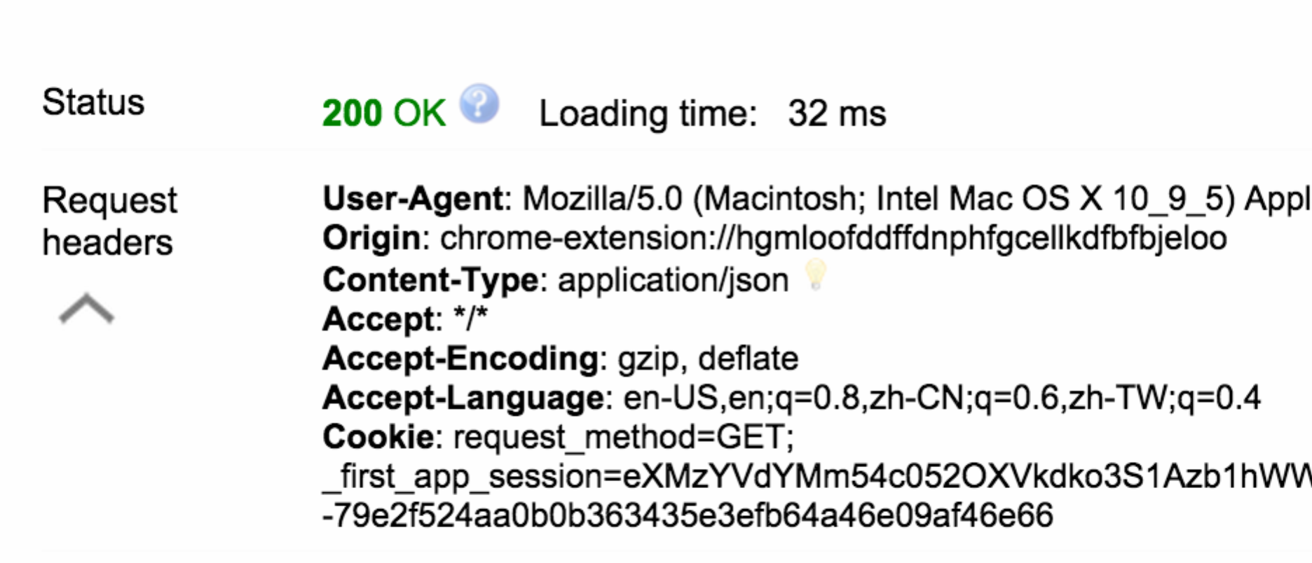

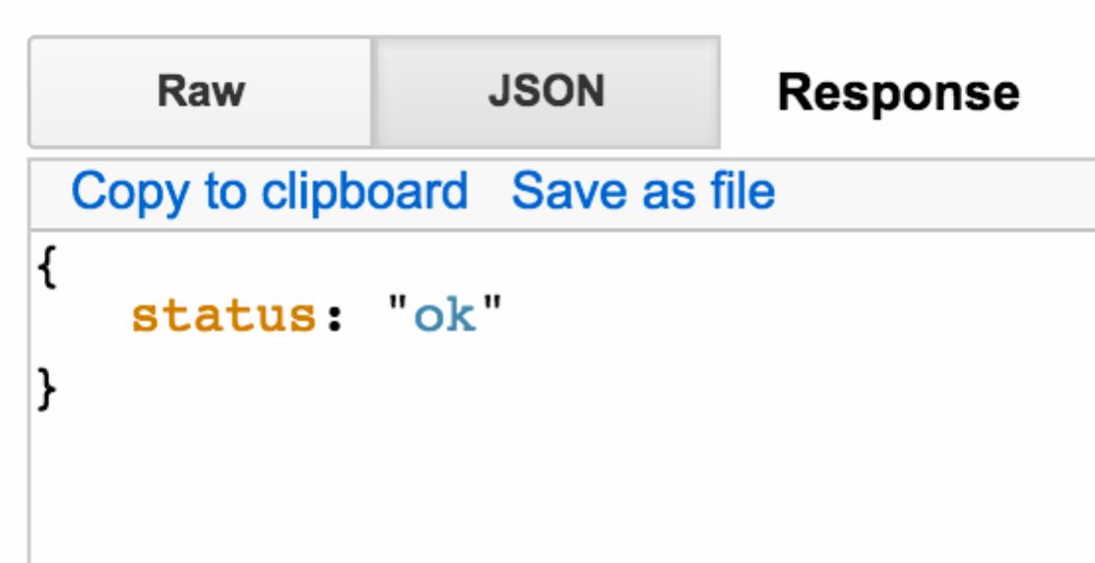

The result:

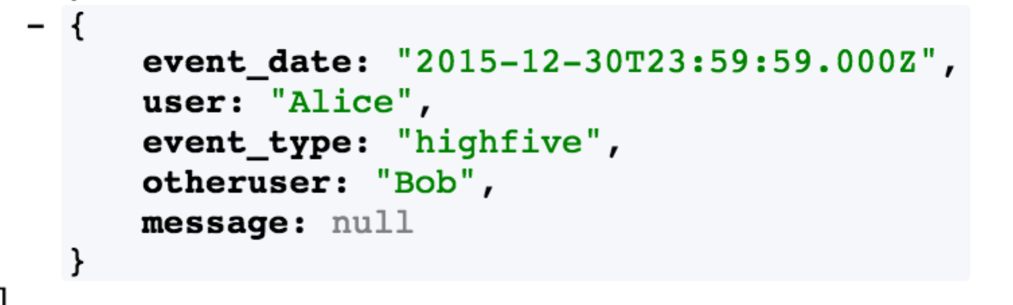

User leaves the room:

{"event_date":"2014-12-31T23:59:59Z", "user": "Alice", "event_type": "leave"}

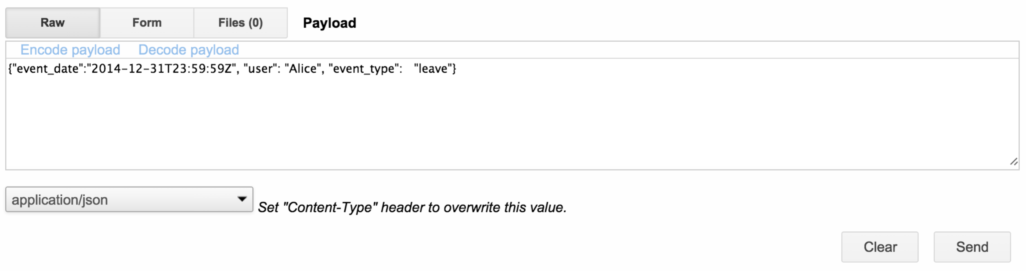

Result:

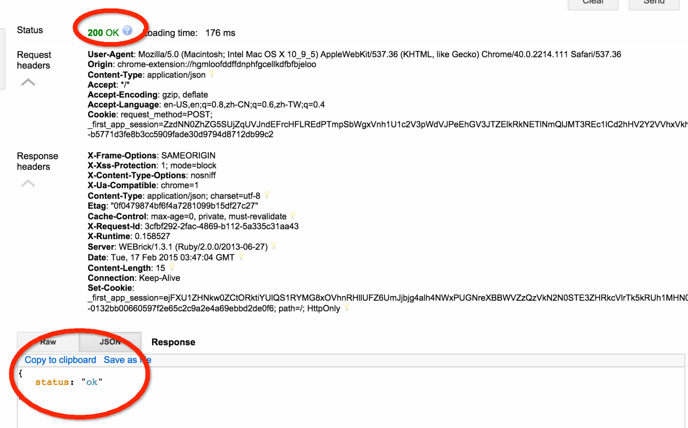

The event is added to the event list:

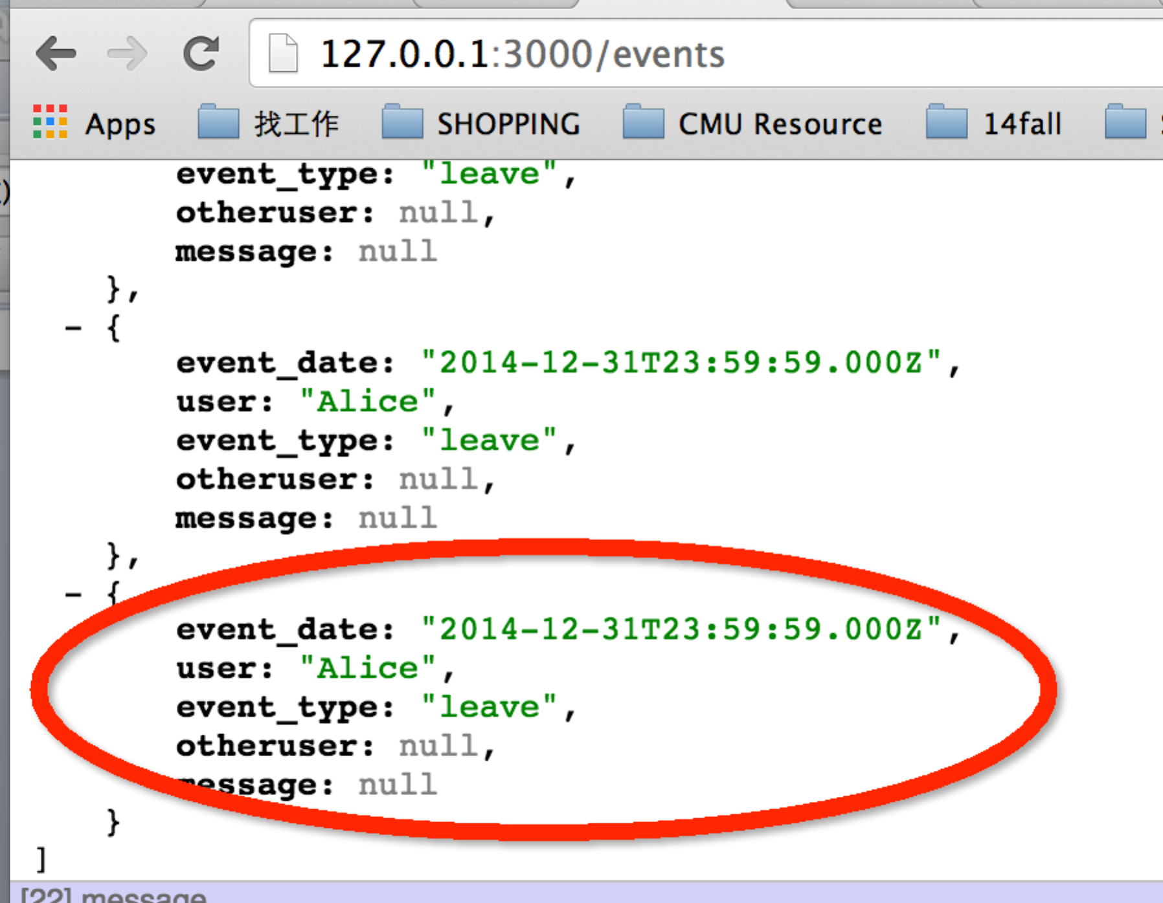

* **Event Details**

**GET /events?from=DATE&to=DATE**

1. **Test Case 1:**

<http://127.0.0.1:3000/events?from=2015-02-15T23:53:00Z&to=2015-02-16T23:53:55Z>

The result:

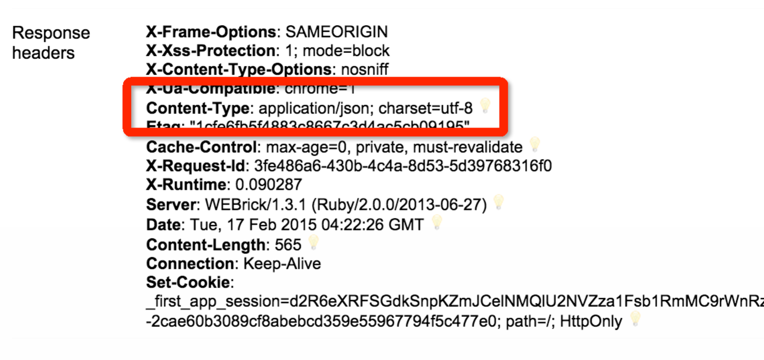

[

* {
  + **event_date**: "2015-02-15T23:53:00.000Z",
  + **user**: "Alice",
  + **event_type**: "enter",
  + **otheruser**: "",
  + **message**: ""

},

* {
  + **event_date**: "2015-02-15T23:54:00.000Z",
  + **user**: "Alice",
  + **event_type**: "comment",
  + **otheruser**: "",
  + **message**: "Hello, world!"

},

* {
  + **event_date**: "2015-02-15T23:54:00.000Z",
  + **user**: "Alice",
  + **event_type**: "highfive",
  + **otheruser**: "Bob",
  + **message**: ""

},

* {
  + **event_date**: "2015-02-15T23:57:00.000Z",
  + **user**: "Alice",
  + **event_type**: "leave",
  + **otheruser**: "",
  + **message**: ""

},

* {
  + **event_date**: "2015-02-15T23:53:00.000Z",
  + **user**: "Atom",
  + **event_type**: "enter",
  + **otheruser**: "",
  + **message**: ""

},

* {
  + **event_date**: "2015-02-15T23:54:00.000Z",
  + **user**: "Atom",
  + **event_type**: "comment",
  + **otheruser**: "",
  + **message**: "Hi, I am atom"

},

* {
  + **event_date**: "2015-02-16T07:37:00.000Z",
  + **user**: "Atom",
  + **event_type**: "enter",
  + **otheruser**: "",
  + **message**: ""

},

* {
  + **event_date**: "2015-02-16T10:36:00.000Z",
  + **user**: "Zhu",
  + **event_type**: "enter",
  + **otheruser**: "",
  + **message**: ""

},

* {
  + **event_date**: "2015-02-16T10:36:00.000Z",
  + **user**: "Atom",
  + **event_type**: "leave",
  + **otheruser**: "",
  + **message**: ""

}

]

1. **Test Case 2:**

<http://127.0.0.1:3000/events?from=2015-02-15T23:53:00Z&to=2015-02-15T23:54:55Z>

The result:

[{"event_date":"2015-02-15T23:53:00.000Z","user":"Alice","event_type":"enter","otheruser":"","message":""},{"event_date":"2015-02-15T23:54:00.000Z","user":"Alice","event_type":"comment","otheruser":"","message":"Hello, world!"},{"event_date":"2015-02-15T23:54:00.000Z","user":"Alice","event_type":"highfive","otheruser":"Bob","message":""},{"event_date":"2015-02-15T23:53:00.000Z","user":"Atom","event_type":"enter","otheruser":"","message":""},{"event_date":"2015-02-15T23:54:00.000Z","user":"Atom","event_type":"comment","otheruser":"","message":"Hi, I am atom"}]

* **Event Summary**

**GET /summary?from=DATE&to=DATE&by=TIMEFRAME**

**First show all the date:**

**http://127.0.0.1:3000/events**

[

* {
  + **event_date**: "2015-02-15T23:53:00.000Z",
  + **user**: "Alice",
  + **event_type**: "enter",
  + **otheruser**: "",
  + **message**: ""

},

* {
  + **event_date**: "2015-02-15T23:54:00.000Z",
  + **user**: "Alice",
  + **event_type**: "comment",
  + **otheruser**: "",
  + **message**: "Hello, world!"

},

* {
  + **event_date**: "2015-02-15T23:54:00.000Z",
  + **user**: "Alice",
  + **event_type**: "highfive",
  + **otheruser**: "Bob",
  + **message**: ""

},

* {
  + **event_date**: "2015-02-15T23:57:00.000Z",
  + **user**: "Alice",
  + **event_type**: "leave",
  + **otheruser**: "",
  + **message**: ""

},

* {
  + **event_date**: "2015-02-15T23:53:00.000Z",
  + **user**: "Atom",
  + **event_type**: "enter",
  + **otheruser**: "",
  + **message**: ""

},

* {
  + **event_date**: "2015-02-15T23:54:00.000Z",
  + **user**: "Atom",
  + **event_type**: "comment",
  + **otheruser**: "",
  + **message**: "Hi, I am atom"

},

* {
  + **event_date**: "2015-02-16T07:37:00.000Z",
  + **user**: "Atom",
  + **event_type**: "enter",
  + **otheruser**: "",
  + **message**: ""

},

* {
  + **event_date**: "2015-02-16T10:36:00.000Z",
  + **user**: "Zhu",
  + **event_type**: "enter",
  + **otheruser**: "",
  + **message**: ""

},

* {
  + **event_date**: "2015-02-16T10:36:00.000Z",
  + **user**: "Atom",
  + **event_type**: "leave",
  + **otheruser**: "",
  + **message**: ""

},

* {
  + **event_date**: "2007-12-31T23:59:59.000Z",
  + **user**: "Alice",
  + **event_type**: "enter",
  + **otheruser**: null,
  + **message**: null

},

* {
  + **event_date**: "2014-12-31T23:59:59.000Z",
  + **user**: "Alice",
  + **event_type**: "enter",
  + **otheruser**: null,
  + **message**: null

},

* {
  + **event_date**: "2014-12-31T23:59:59.000Z",
  + **user**: "Alice",
  + **event_type**: "enter",
  + **otheruser**: null,
  + **message**: null

},

* {
  + **event_date**: "2014-12-31T23:59:59.000Z",
  + **user**: "Alice",
  + **event_type**: "enter",
  + **otheruser**: null,
  + **message**: null

},

* {
  + **event_date**: "2014-12-31T23:59:59.000Z",
  + **user**: "Alice",
  + **event_type**: "enter",
  + **otheruser**: null,
  + **message**: null

},

* {
  + **event_date**: "2014-12-31T23:59:59.000Z",
  + **user**: "Alice",
  + **event_type**: "enter",
  + **otheruser**: null,
  + **message**: null

},

* {
  + **event_date**: "2014-12-31T23:59:59.000Z",
  + **user**: "Alice",
  + **event_type**: "comment",
  + **otheruser**: null,
  + **message**: "hello, this is a sample message"

},

* {
  + **event_date**: "2014-12-31T23:59:59.000Z",
  + **user**: "Alice",
  + **event_type**: "comment",
  + **otheruser**: null,
  + **message**: "hello, this is a sample message"

},

* {
  + **event_date**: "2014-12-31T23:59:59.000Z",
  + **user**: "Alice",
  + **event_type**: "highfive",
  + **otheruser**: "Bob",
  + **message**: null

},

* {
  + **event_date**: "2014-12-31T23:59:59.000Z",
  + **user**: "Alice",
  + **event_type**: "leave",
  + **otheruser**: null,
  + **message**: null

},

* {
  + **event_date**: "2014-12-31T23:59:59.000Z",
  + **user**: "Alice",
  + **event_type**: "leave",
  + **otheruser**: null,
  + **message**: null

},

* {
  + **event_date**: "2014-12-31T23:59:59.000Z",
  + **user**: "Alice",
  + **event_type**: "leave",
  + **otheruser**: null,
  + **message**: null

},

* {
  + **event_date**: "2014-12-31T23:59:59.000Z",
  + **user**: "Alice",
  + **event_type**: "leave",
  + **otheruser**: null,
  + **message**: null

},

* {
  + **event_date**: "2014-12-31T23:59:59.000Z",
  + **user**: "Alice",
  + **event_type**: "leave",
  + **otheruser**: null,
  + **message**: null

},

* {
  + **event_date**: "2014-12-31T23:59:59.000Z",
  + **user**: "Alice",
  + **event_type**: "leave",
  + **otheruser**: null,
  + **message**: null

},

* {
  + **event_date**: "2015-12-30T23:59:59.000Z",
  + **user**: "Alice",
  + **event_type**: "enter",
  + **otheruser**: null,
  + **message**: null

},

* {
  + **event_date**: "2015-12-30T23:59:59.000Z",
  + **user**: "Alice",
  + **event_type**: "comment",
  + **otheruser**: null,
  + **message**: "hello, this is a sample message"

},

* {
  + **event_date**: "2015-12-30T23:59:59.000Z",
  + **user**: "Alice",
  + **event_type**: null,
  + **otheruser**: "Bob",
  + **message**: null

},

* {
  + **event_date**: "2015-12-30T23:59:59.000Z",
  + **user**: "Alice",
  + **event_type**: "highfive",
  + **otheruser**: "Bob",
  + **message**: null

},

* {
  + **event_date**: "2015-12-30T23:59:59.000Z",
  + **user**: "Alice",
  + **event_type**: "highfive",
  + **otheruser**: "Bob",
  + **message**: null

}

]

### TIMEFRAME: Hour:

1. <http://127.0.0.1:3000/summary?from=2013-02-15T23:53:00Z&to=2016-02-15T23:53:55Z&by=hour>

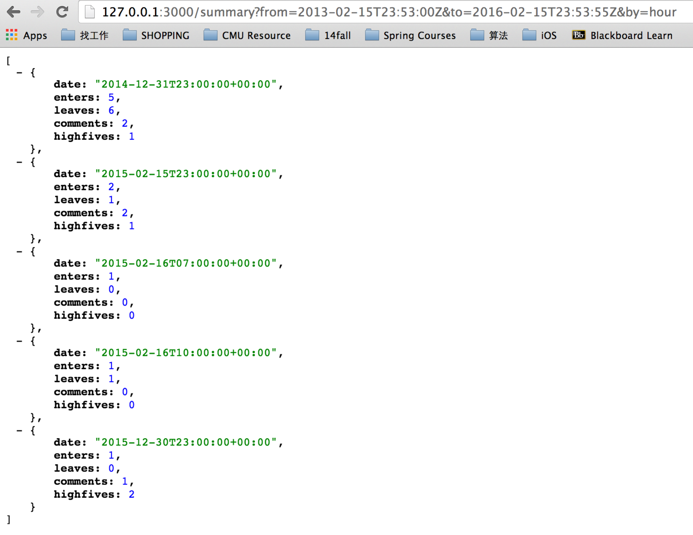

1. <http://127.0.0.1:3000/summary?from=2013-02-15T23:53:00Z&to=2015-02-15T23:53:55Z&by=hour>

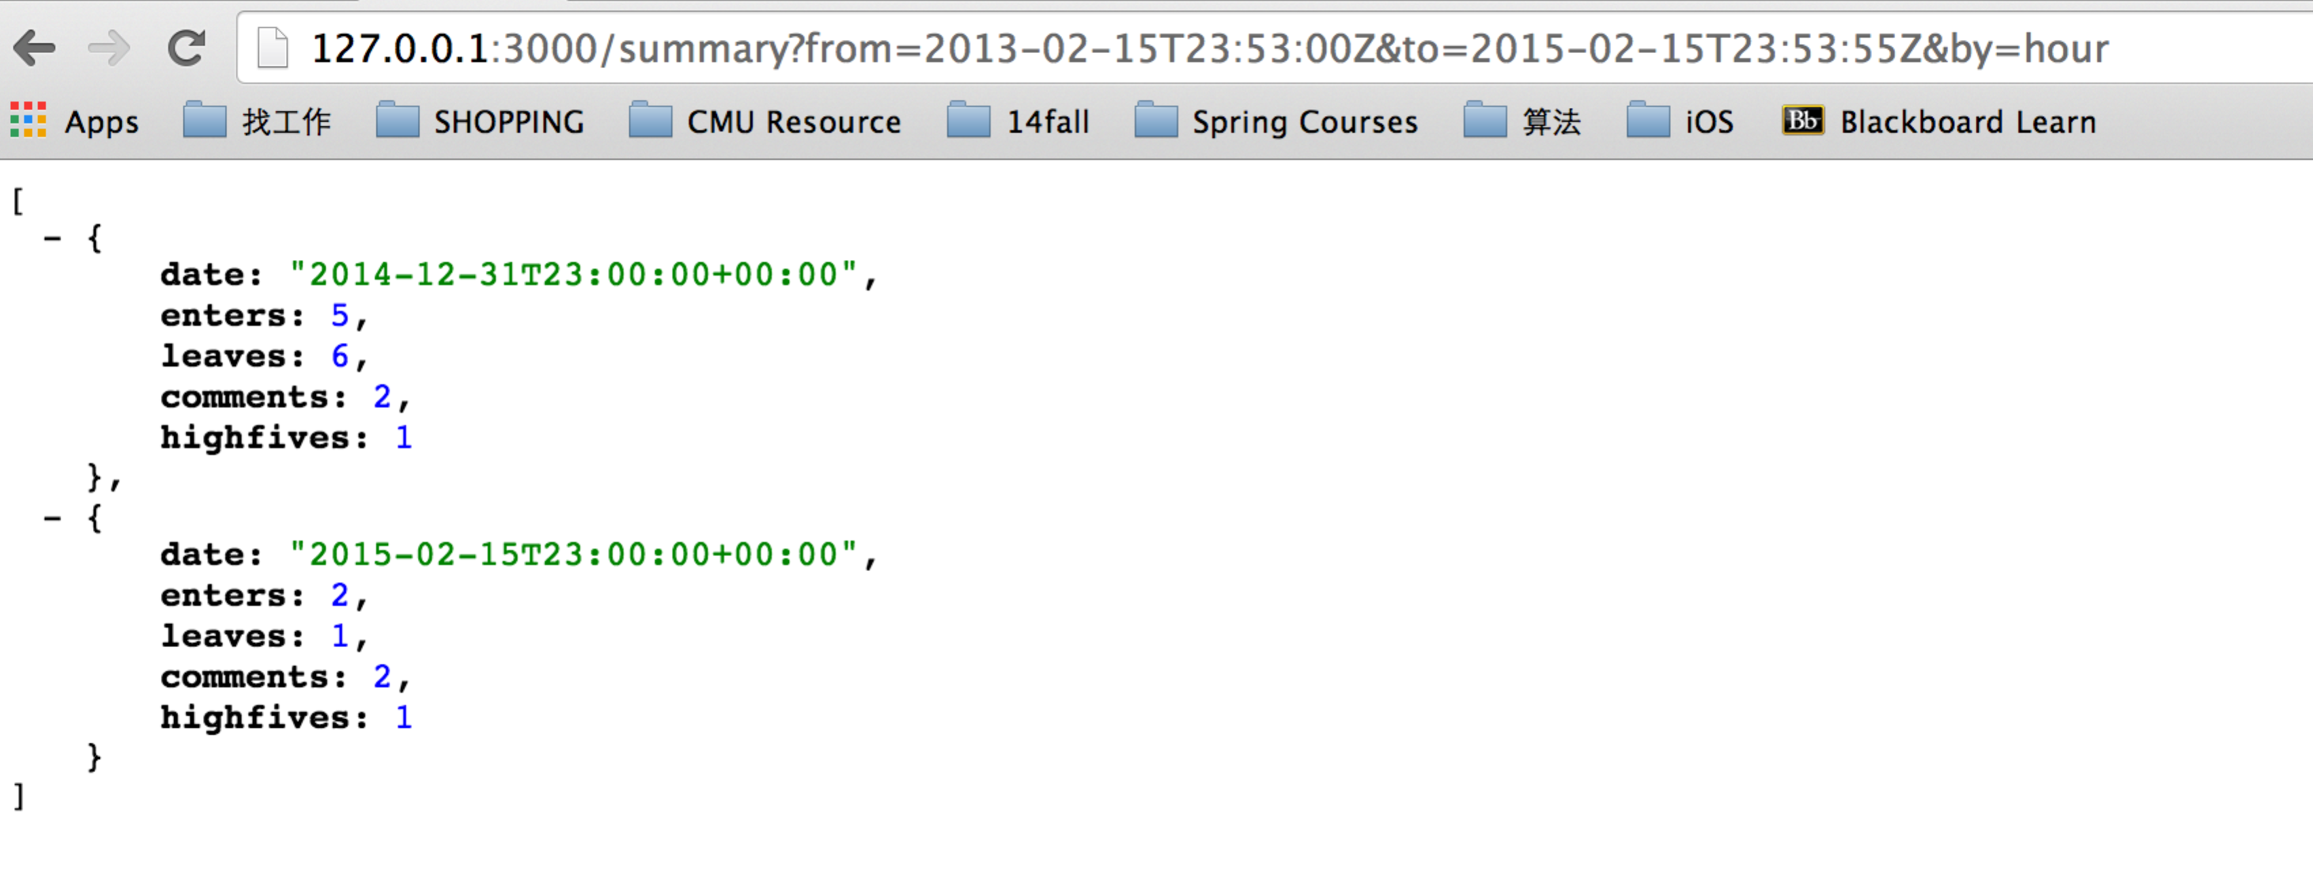

### TIMEFRAME: Day:

<http://127.0.0.1:3000/summary?from=2013-02-15T23:53:00Z&to=2016-02-15T23:53:55Z&by=day>

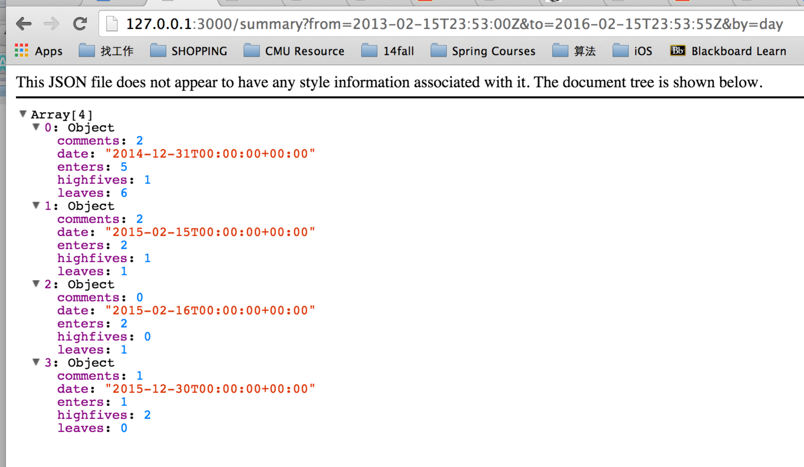

### TIMEFRAME: Minute:

<http://127.0.0.1:3000/summary?from=2013-02-15T23:53:00Z&to=2016-02-15T23:53:55Z&by=minute>

[

* {
  + **date**: "2014-12-31T23:59:00+00:00",
  + **enters**: 5,
  + **leaves**: 6,
  + **comments**: 2,
  + **highfives**: 1

},

* {
  + **date**: "2015-02-15T23:53:00+00:00",
  + **enters**: 2,
  + **leaves**: 0,
  + **comments**: 0,
  + **highfives**: 0

},

* {
  + **date**: "2015-02-15T23:54:00+00:00",
  + **enters**: 0,
  + **leaves**: 0,
  + **comments**: 2,
  + **highfives**: 1

},

* {
  + **date**: "2015-02-15T23:57:00+00:00",
  + **enters**: 0,
  + **leaves**: 1,
  + **comments**: 0,
  + **highfives**: 0

},

* {
  + **date**: "2015-02-16T07:37:00+00:00",
  + **enters**: 1,
  + **leaves**: 0,
  + **comments**: 0,
  + **highfives**: 0

},

* {
  + **date**: "2015-02-16T10:36:00+00:00",
  + **enters**: 1,
  + **leaves**: 1,
  + **comments**: 0,
  + **highfives**: 0

},

* {
  + **date**: "2015-12-30T23:59:00+00:00",
  + **enters**: 1,
  + **leaves**: 0,
  + **comments**: 1,
  + **highfives**: 2

}

]